**Developing Blockchain App Using Ethereum**

Tools Required:

1. Node.js / npm (<https://nodejs.org/en/>) (After Installation, Check Version on Terminal using commands: npm -v & node -v)
2. Truffle (Terminal Command: npm install -g truffle)
3. Ethereumjs-testrpc (npm install -g ethereumjs-testrpc) or (sudo npm install -g ganache-cli)

Steps:

1. > mkdir greeterApp
2. > cd greeterApp
3. > mkdir greeter
4. > cd greeter
5. > truffle init
6. The above command will create few folders like contracts, migrations, test, truffle.js
7. > cd contracts
8. Create a new file name ***Greeter.sol*** inside contracts folder (*This is a contract file using Solidity language*)
9. Content of ***Greeter.sol***

pragma solidity ^0.4.13;

contract Greeter {

string greeting;

function greeter(string _greeting) public {

greeting = _greeting;

}

function greet() constant returns (string) {

return greeting;

}

}

1. Change **migrations/deploy_contracts.js** file

var Greeter = artifacts.require("./Greeter.sol");

module.exports = function(deployer) {

deployer.deploy(Greeter);

};

1. Change truffle.js

module.exports = {

networks: {

development: {

host: "localhost",

port: 8545,

network_id: "*" // Match any network id

}

}

};

1. Open a new terminal and type ‘ganache-cli’ or ‘testrpc’ (depends upon which testing framework you installed from Tools Required#3)
2. > truffle compile (this would compile your solidity code and creates a new ***build*** folder)

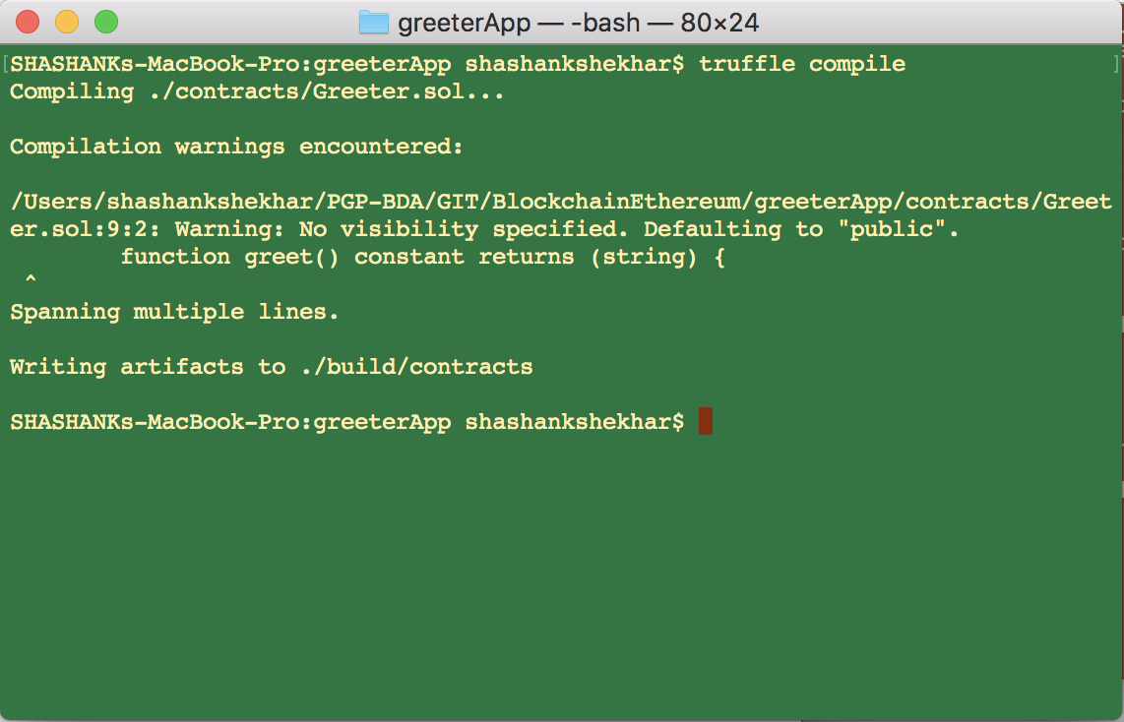

1. > truffle migrate

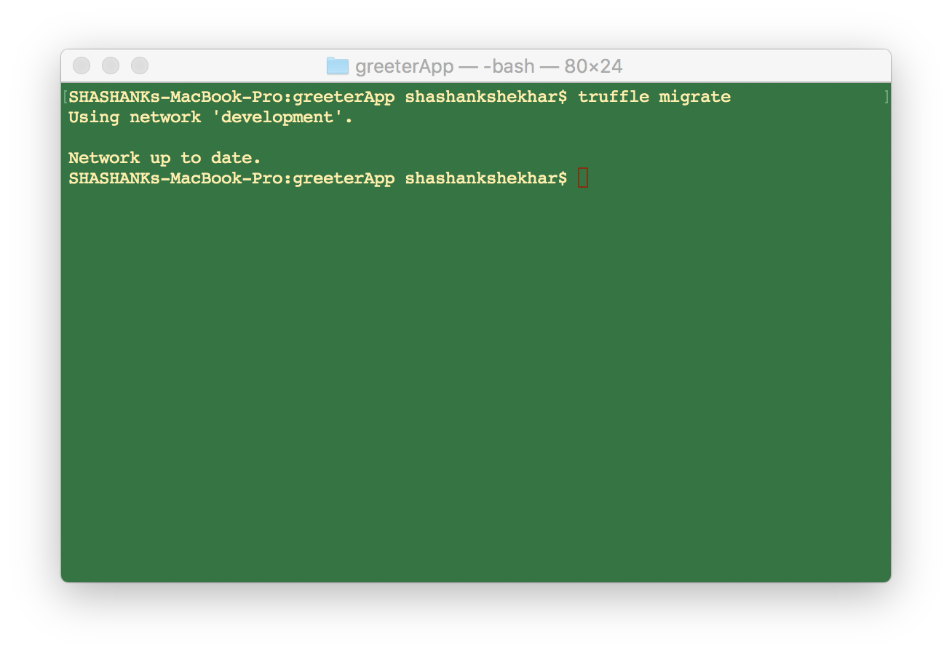

1. Truffle console

